**Ideation Phase**

**Brainstorm & Idea Prioritization Template**

|  |  |
| --- | --- |
| Date | 26 June 2025 |
| Team ID | LTVIP2025TMID59601 |
| Project Name | OrderOnTheGo: Your On-Demand Food Ordering Solution |
| Maximum Marks | 4 Marks |

**Brainstorm & Idea Prioritization Template:**

**Step-1: Team Gathering, Collaboration and Select the Problem Statement**

**Define your problem statement:** "How might we create a seamless and efficient food ordering and delivery experience that benefits both customers and local restaurants?"

**Key rules of brainstorming:**

* Encourage wild ideas
* Defer judgments
* Go for volume
* Be visual
* One conversation at a time

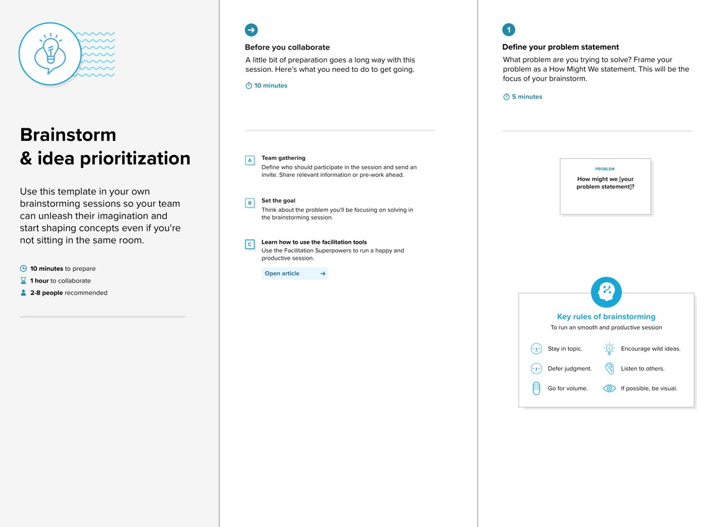

**Step-2: Brainstorm, Idea Listing and Grouping**

**Brainstorm ideas that address your problem statement**

**Customer-Centric Ideas:**

* User-friendly interface for browsing menus.
* Real-time order tracking with map integration.
* Multiple payment options (COD, Card).
* Personalized recommendations based on past orders.
* Ability to save favourite restaurants/dishes.
* Easy re-ordering from past orders.
* Customer rating and review system for restaurants/food items.
* Push notifications for order status updates.
* In-app chat with delivery person.

**Restaurant-Centric Ideas:**

* Dashboard for restaurant owners to manage orders.
* Easy menu item adding/editing with photos.
* Notification system for new incoming orders.
* Tools for managing restaurant hours and availability.
* Performance analytics for restaurants (popular items, sales).
* System for accepting/rejecting orders.
* Feedback channel from restaurant owners to admin.
* Promotional tools for restaurants (discounts, specials).

**Admin/Platform-Centric Ideas:**

* Admin dashboard for system oversight.
* User and restaurant approval/management.
* Global category management.
* Comprehensive reporting (sales, trends, popular categories).
* Ability to send announcements/promotions to users.
* Manage promoted restaurants.
* System for handling user/restaurant feedback to admin.

**Grouping Ideas (Example categories):**

* **User Experience:** User-friendly interface, personalized recommendations, real-time tracking, easy re-ordering.
* **Restaurant Operations:** Owner dashboard, menu management, order processing, performance analytics.
* **Platform Management:** Admin dashboard, user/restaurant approval, category management, reporting, announcements.
* **Engagement & Feedback:** Rating/review system, in-app chat, feedback channels.

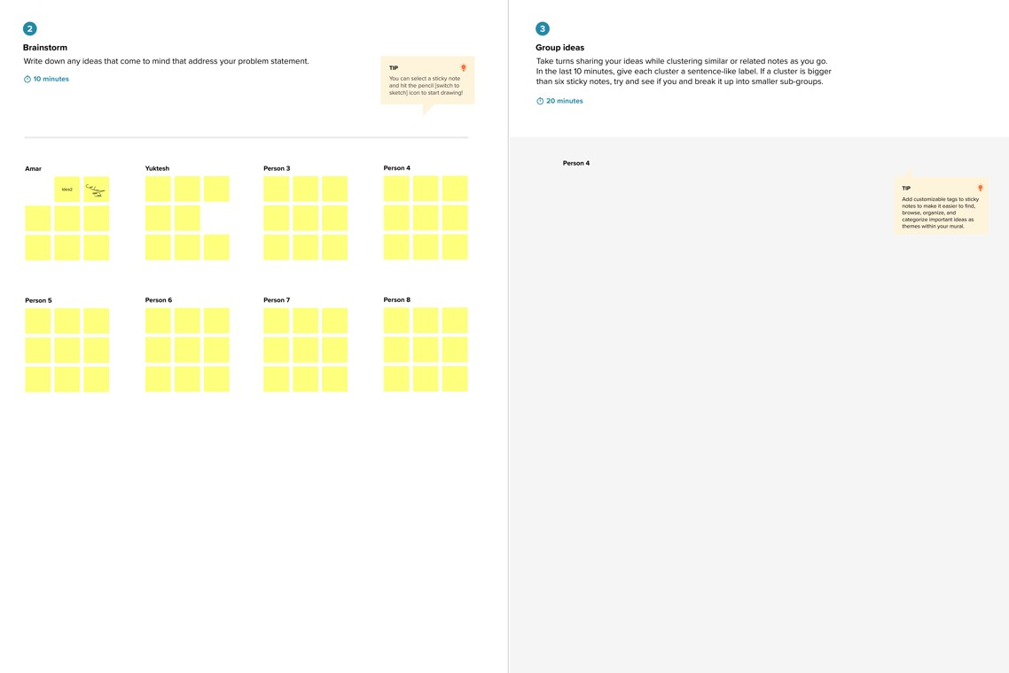

**Step-3: Idea Prioritization**

Prioritize ideas based on **Importance** (impact on users/business) vs. **Feasibility** (ease of implementation, resources n

